ICA Joint Meeting on Atlases and Education

1./2. September 2016 ETH Campus Hönggerberg, Zurich, Switzerland

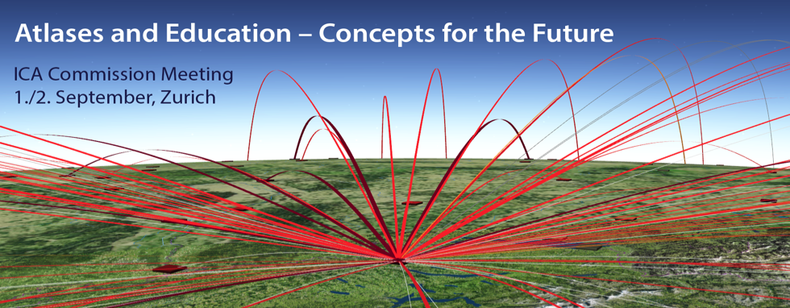

First Circular: Invitation and Call for Contributions

Dear Colleagues,

The *ICA Commissions on Atlases and on Education and Training* are happy to announce and invite you to a

**Joint Meeting and Workshop: «Atlases and Education –Concepts for the Future»**

Atlas cartography and educational cartography are undergoing a renewal process, due to technology-driven forces and altered user demands. The goal of this meeting is to present and talk about new ideas and concepts in both fields of atlas and education cartography.

|  |
| --- |
| **Meeting program** |
| * The first day of the meeting will be dedicated to keynotes and state-of-the-art contributions. * During the second day, we plan to present and discuss future atlas and educational concepts. |

|  |
| --- |
| **Social program** |
| * We are planning to visit Zurich’s famous map library (Zentralbibliothek), the old town, and take a tour on the Uetliberg, Zurich’s nearest mountain spot. |

*David Fairbairn, Chair of the ICA Commission on Education and Training*

*René Sieber, Chair of the ICA Commission on Atlases*

|  |
| --- |
| **Presentations and papers** |
| * **Presentation on invitation** We are proud to announce *Ferjan Ormeling (Prof. emer.)* as invited speaker; he has sound knowledge in both atlases and educational cartography. * **Oral presentations** Depending on the number of contributions, the presentation time will be 15 or 20 minutes.  The presentation should refer to the meeting’s topic (and hopefully contain fresh ideas). *Please indicate the title of your contribution on the registration form.* * **Abstracts** An abstract with a maximum of 500 words – including 1-2 figures – is mandatory in order to accept your contribution for oral presentation. *Please send the abstract to the email-address on the registration form.* * **Full Papers** After the meeting, we are planning to publish a selection of the papers in a special issue of the *International Journal of Cartography.* |

|  |  |
| --- | --- |
| **Deadlines** |  |
| **July 31, 2016**  **August 15, 2016** | **Registration and Announcement of paper**  **Abstract** |

|  |  |
| --- | --- |
| **Registration Form** | **Meeting on Atlases and Education** |
| **First / Second Name** |  |
| **Affiliation** |  |
| **Address** |  |
| **Country** |  |
| **E-mail** |  |

|  |  |
| --- | --- |
| **Presentation Title** (prov.) |  |

**Please notice:**

To present a paper is not a condition for participation.

No registration or participation fee is requested.

A **2nd Circular** with a detailed program of the meeting and other activities will follow after the deadline for registration.